**Practical no: 3**

**Aim:- Study and implementation of software as a Service.**

**Theory:**

Software as a service (SaaS) is a software distribution model in which a cloud provider hosts applications and makes them available to end users over the internet. In this model, an independent software vendor (ISV) may contract a third-party cloud provider to host the application. Or, with larger companies, such as Microsoft, the cloud provider might also be the software vendor

SaaS is one of three main categories of cloud computing, alongside infrastructure as a service (IaaS) and platform as a service (PaaS). A range of IT professionals, business users and personal users use SaaS applications. Products range from personal entertainment, such as Netflix, to advanced IT tools. Unlike IaaS and PaaS, SaaS products are frequently marketed to both B2B and B2C users

According to a recent McKinsey & Company report, technology industry analysts predict further growth in the software as a service market, and expect to see the market for SaaS products near $200 billion by 2024.

There are the following services provided by SaaS providers - Business Services - SaaS Provider provides various business services to start-up the business. The SaaS business services include ERP (Enterprise Resource Planning), CRM (Customer Relationship Management), billing, and sales.

Document Management - SaaS document management is a software application offered by a third party (SaaS providers) to create, manage, and track electronic documents.

**How does software as a service work?**

SaaS works through the cloud delivery model. A software provider will either host the application and related data using its own servers, databases, networking and computing resources, or it may be an ISV that contracts a cloud provider to host the application in the provider's data center. The application will be accessible to any device with a network connection. SaaS applications are typically accessed via web browsers.

**Code and steps:-**

**1. Goto www.google.com**

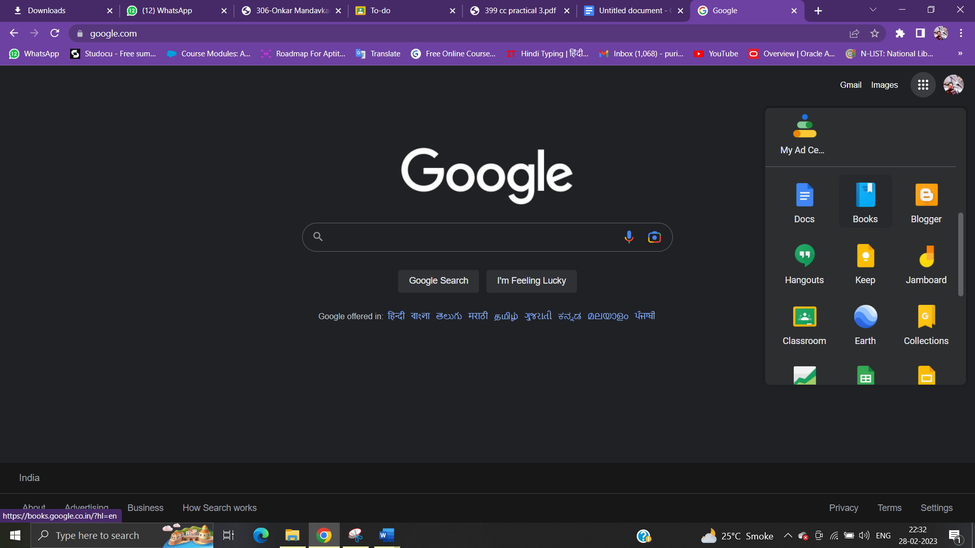

2. Goto Google apps

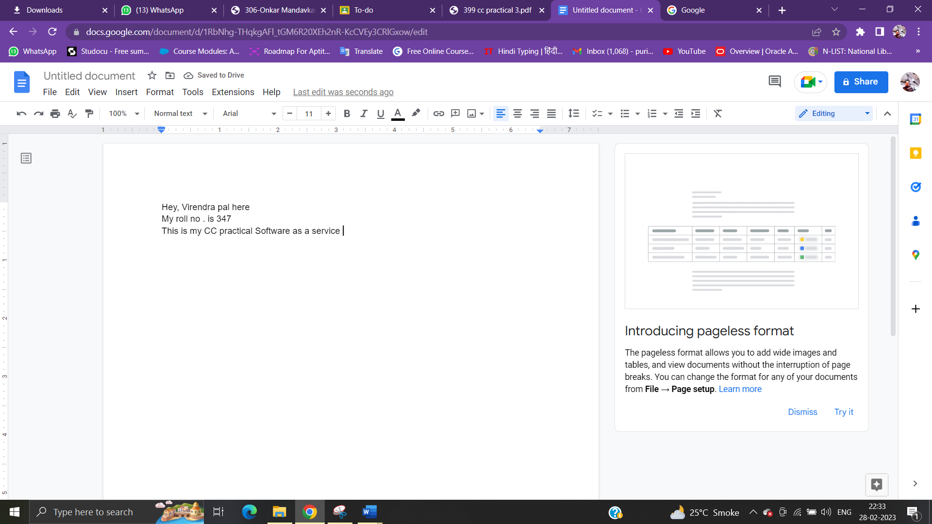

3. open google doc and write anything and save it in google drive.

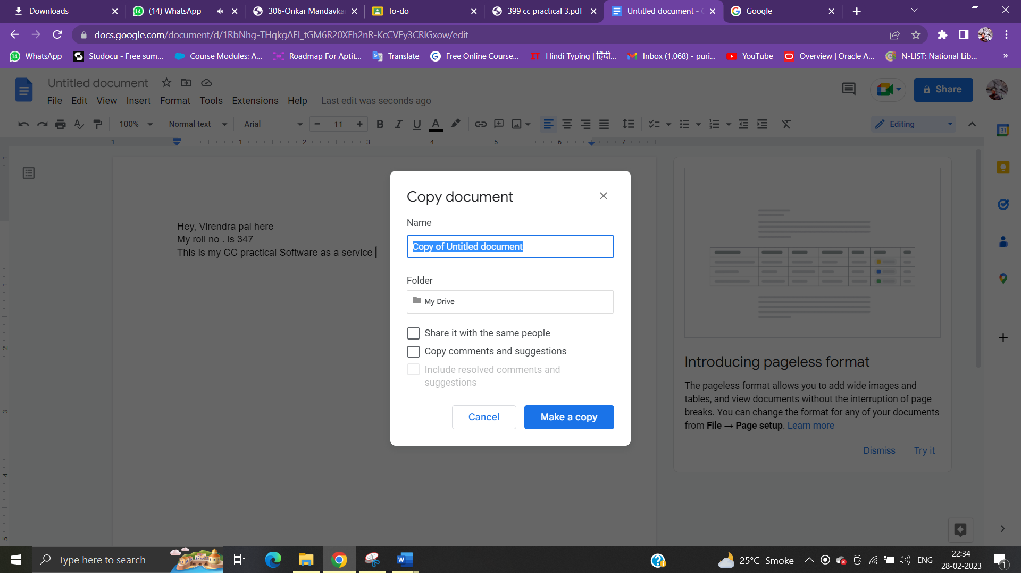

4. now open google sheets and type anything and save it in drive.

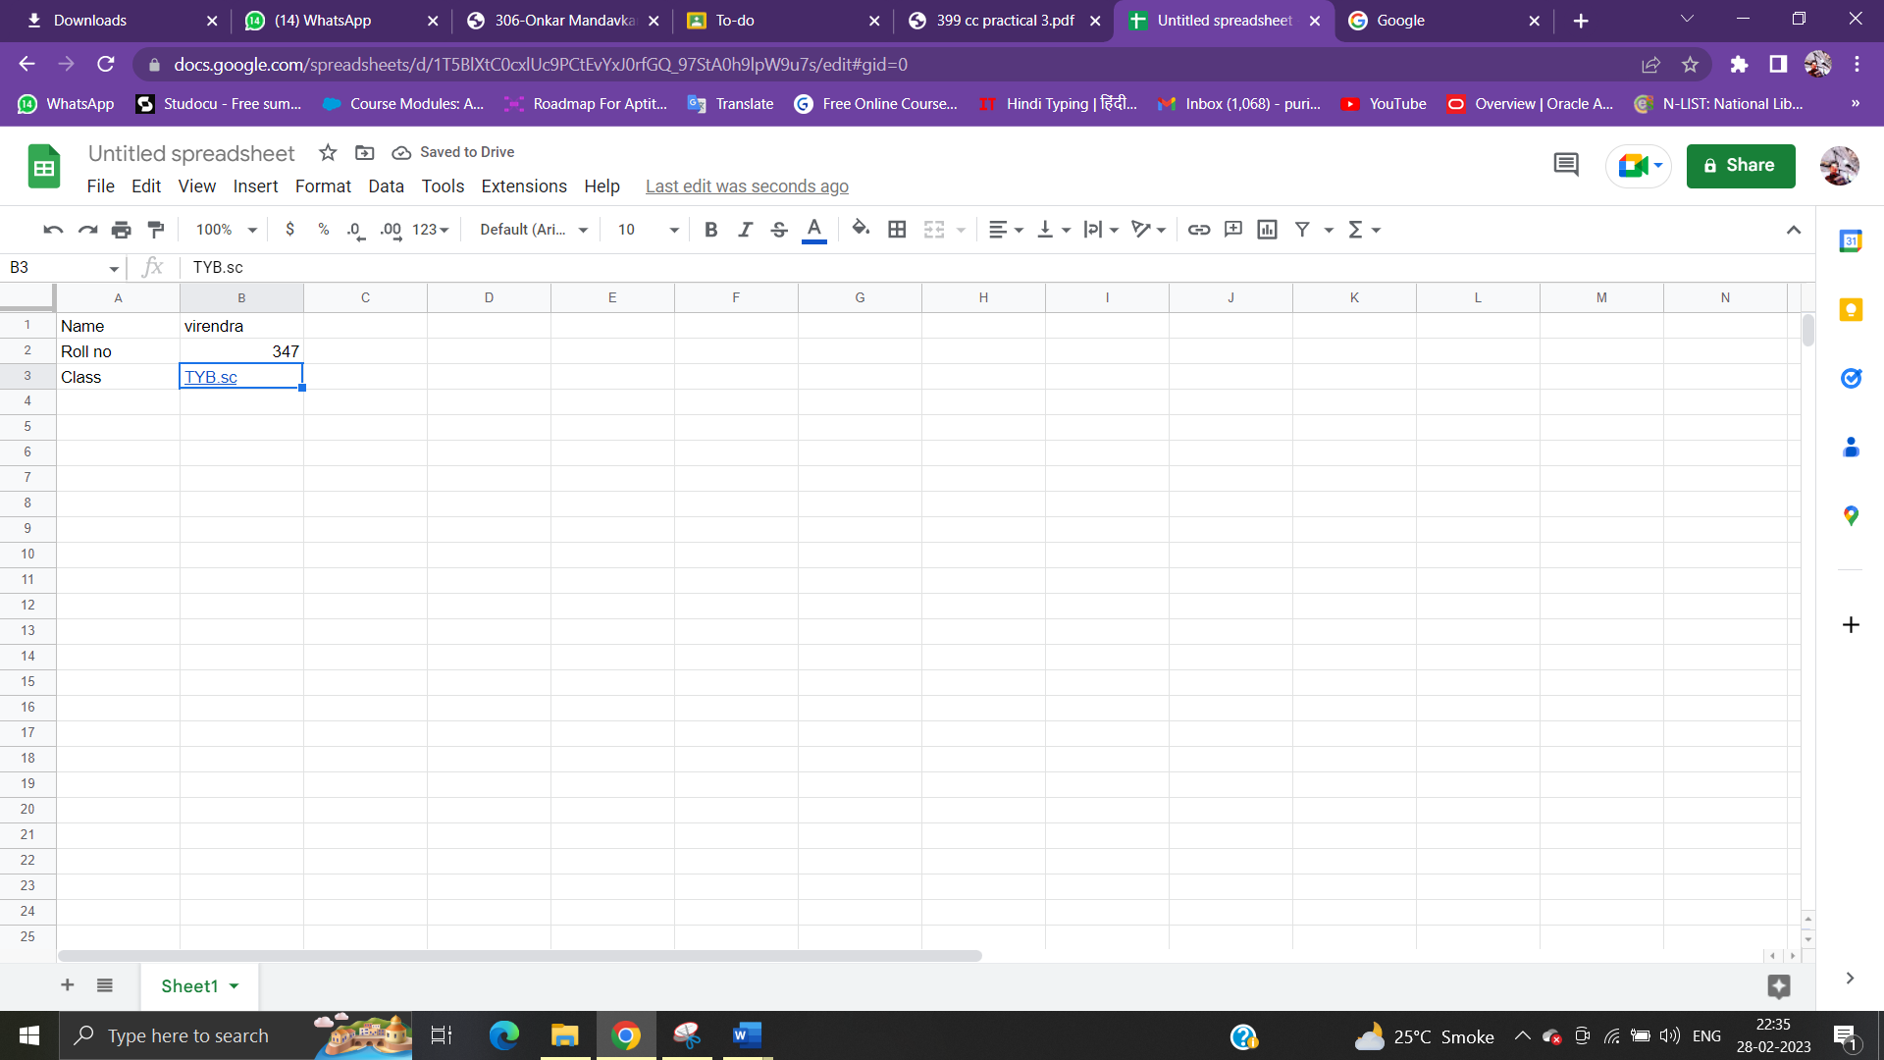

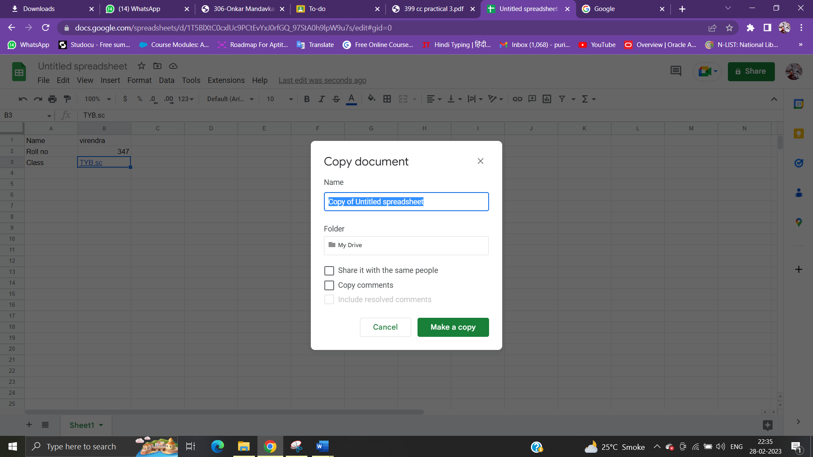

5. now open google forms and save it in drive.

